**LAB 9**

**K20-1052(S.M.HASSAN ALI)**

**Q1,**

#include <iostream>

using namespace std;

class InDec{

int n1;

public:

InDec(int a):n1(a){

}

func(){

cout<<"The number before prefix and postfix is: "<<n1<<endl<<endl;

}

func1(){

cout<<"PREFIX: the number after the multiplication by 4 is: "<<n1<<endl<<endl;

}

func2(){

cout<<"POSTFIX: the number after the divison by 4 is: "<<n1<<endl<<endl;

}

void operator--(){

n1=n1*4;

}

void operator--(int i){

i=4;

n1=n1/4;

}

};

int main(){

InDec a(44);

a.func();

--a;

a.func1();

a--;

a.func2();

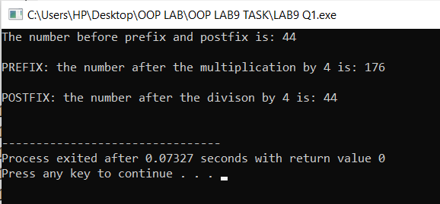}

**Q2.**

#include <iostream>

using namespace std;

class Shape{

int a,b;

public:

Shape(int i, int j):a(i),b(j){}

func(){

cout<<" Area is: "<<a*b<<endl<<endl;

}

Shape operator+(Shape s){

s.a=s.a+a;

s.b=s.b+b;

return s;

}

};

int main(){

Shape shape1(3,5),shape2(6,10);

cout<<"Shape1 ";

shape1.func();

cout<<"Shape2 ";

shape2.func();

Shape shape3=shape1+shape2;

cout<<"Shape1 + Shape2 ";

shape3.func();

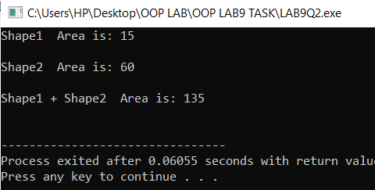}

**Q3.**

#include <iostream>

using namespace std;

class Perimeter;

class Printclass{

int l,b;

public:

void peri(Perimeter &);

};

class Perimeter{

int len,bre;

public:

Perimeter(int a,int b):len(a),bre(b){

cout<<"LENGTH: "<<len<<endl<<endl;

cout<<"BREATH: "<<bre<<endl<<endl;

}

friend class Printclass;

};

void Printclass::peri(Perimeter &a){

l = l + a.len*2;

b = b + a.bre*2;

cout<<"The perimeter of object Rectangle is 2(L+B): "<<l+b<<endl;

}

int main(){

Printclass c;

Perimeter p(10,9);

c.peri(p);

}

